Lab Assignment NO 4

AIM:-

Create a Linear Regression Model using Python/R to predict home prices using Boston Housing

Dataset (https://[www.kaggle.com/c/boston-housing).](http://www.kaggle.com/c/boston-housing)) The Boston Housing dataset contains

information about various houses in Boston through different parameters. There are 506 samples

and 14 feature variables in this dataset.

The objective is to predict the value of prices of the house using the given features

import pandas as pd import numpy as np

import matplotlib.pyplot as plt

x=np.array([95,85,80,70,60])

y=np.array([85,95,70,65,70])

model=np.polyfit(x, y, 1) model

array([ 0.64383562, 26.78082192])

predict=np.poly1d(model) predict(65)

68.63013698630137

y_pred= predict (x) y_pred

array([87.94520548, 81.50684932, 78.28767123, 71.84931507,

65.4109589 ])

from sklearn.metrics import r2_score r2_score(y, y_pred)

0.4803218090889326

y_line= model[1] + model[0]*x plt.plot(x, y_line, c='r') plt.scatter(x, y_pred) plt.scatter(x, y, c='r')

<matplotlib.collections.PathCollection at 0x1e79c2ba890>

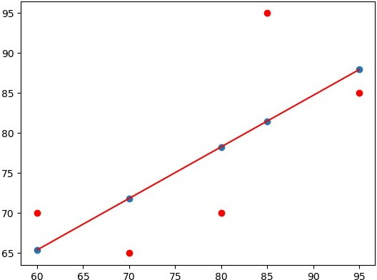

*#import numpy as np #import pandas as pd*

*#import matplotlib.pyplot as plt*

from sklearn.datasets import fetch_openml

from sklearn.datasets import fetch_california_housing housing = fetch_california_housing()

housing

{'data': array([[ 2.55555556,

8.3252

, 41.

,

6.98412698, ...,

2.10984183,

2.80225989,

37.85

...,

[ 1.7

2.3256351 ,

, -122.24

],

,

17.

,

5.20554273, ...,

2.12320917,

|  |  |  |  |  |  |
| --- | --- | --- | --- | --- | --- |
| 37.88 | , | -122.23 | ], |  | |
| [ 8.3014 | , | 21. | , | 6.23813708, | ..., |

|  |  |  |  |  |  |
| --- | --- | --- | --- | --- | --- |
| 37.86 | , | -122.22 | ], |  | |
| [ 7.2574 | , | 52. | , | 8.28813559, | ..., |

|  |  |  |  |  |  |
| --- | --- | --- | --- | --- | --- |
| 39.43 | , | -121.22 | ], |  | |
| [ 1.8672 | , | 18. | , | 5.32951289, | ..., |

|  |  |  |  |  |  |
| --- | --- | --- | --- | --- | --- |
| 39.43 | , | -121.32 | ], |  | |
| [ 2.3886 | , | 16. | , | 5.25471698, | ..., |

2.61698113,

39.37 , -121.24 ]]),

'target': array([4.526, 3.585, 3.521, ..., 0.923, 0.847, 0.894]),

'frame': None,

'target_names': ['MedHouseVal'],

'feature_names': ['MedInc',

'HouseAge', 'AveRooms',

'AveBedrms',

'Population',

'Longitude'],

'AveOccup', 'Latitude',

'DESCR': '.. _california_housing_dataset:\n\nCalifornia Housing dataset\n--------------------------\n\n**Data Set Characteristics:**\ n\n :Number of Instances: 20640\n\n :Number of Attributes: 8 numeric, predictive attributes and the target\n\n :Attribute

Information:\n - MedInc median income in block group\n

- HouseAge median house age in block group\n - AveRooms average number of rooms per household\n - AveBedrms average number of bedrooms per household\n - Population block group population\n - AveOccup average number of household

members\n - Latitude block group latitude\n -

Longitude block group longitude\n\n :Missing Attribute Values: None\n\nThis dataset was obtained from the StatLib repository.\ [nhttps://www.dcc.fc.up.pt/~ltorgo/Regression/cal_housing.html\n\nThe](http://www.dcc.fc.up.pt/~ltorgo/Regression/cal_housing.html\n\nThe) target variable is the median house value for California districts,\ nexpressed in hundreds of thousands of dollars ($100,000).\n\nThis dataset was derived from the 1990 U.S. census, using one row per census\nblock group. A block group is the smallest geographical unit for which the U.S.\nCensus Bureau publishes sample data (a block group typically has a population\nof 600 to 3,000 people).\n\nA household is a group of people residing within a home. Since the average\nnumber of rooms and bedrooms in this dataset are provided per household, these\ ncolumns may take surprisingly large values for block groups with few households\nand many empty houses, such as vacation resorts.\n\nIt can be downloaded/loaded using the\ n:func:`sklearn.datasets.fetch_california_housing` function.\n\n.. topic:: References\n\n - Pace, R. Kelley and Ronald Barry, Sparse Spatial Autoregressions,\n Statistics and Probability Letters, 33 (1997) 291-297\n'}

data = pd.DataFrame(fetch_california_housing().data) data.columns =fetch_california_housing().feature_names data.head()

MedInc HouseAge AveRooms AveBedrms Population AveOccup Latitude \

0

1

Longitude

-122.23

-122.22

0 8.3252 41.0 6.984127 1.023810 322.0 2.555556

37.88

1 8.3014 21.0 6.238137 0.971880 2401.0 2.109842

37.86

2 7.2574 52.0 8.288136 1.073446 496.0 2.802260

37.85

3 5.6431 52.0 5.817352 1.073059 558.0 2.547945

37.85

4 3.8462 52.0 6.281853 1.081081 565.0 2.181467

37.85

Longitude

0 -122.23

1 -122.22

2 -122.24

3 -122.25

4 -122.25

df=pd.DataFrame(housing.data, columns=housing.feature_names) df

MedInc HouseAge AveRooms AveBedrms Population AveOccup Latitude \

0 8.3252 41.0 6.984127 1.023810 322.0 2.555556

37.88

1 8.3014 21.0 6.238137 0.971880 2401.0 2.109842

37.86

2 7.2574 52.0 8.288136 1.073446 496.0 2.802260

37.85

3 5.6431 52.0 5.817352 1.073059 558.0 2.547945

37.85

4 3.8462 52.0 6.281853 1.081081 565.0 2.181467

37.85

... ... ... ... ... ... ...

...

20635 1.5603 25.0 5.045455 1.133333 845.0 2.560606

39.48

20636 2.5568 18.0 6.114035 1.315789 356.0 3.122807

39.49

20637 1.7000 17.0 5.205543 1.120092 1007.0 2.325635

39.43

20638 1.8672 18.0 5.329513 1.171920 741.0 2.123209

39.43

20639 2.3886 16.0 5.254717 1.162264 1387.0 2.616981

39.37

|  |  |  |
| --- | --- | --- |
|  |  |  |
| 2 | -122.24 |
| 3 | -122.25 |
| 4 | -122.25 |
| ... | ... |
| 20635 | -121.09 |
| 20636 | -121.21 |
| 20637 | -121.22 |
| 20638 | -121.32 |
|  | 20639 | -121.24 |

[20640 rows x 8 columns] data['PRICE'] = housing.target data.isnull().sum()

MedInc 0

HouseAge 0

AveRooms 0

AveBedrms 0

Population 0

AveOccup 0

Latitude 0

Longitude 0

PRICE 0

dtype: int64

x = data.drop(['PRICE'], axis = 1) y = data['PRICE']

from sklearn.model_selection import train_test_split

xtrain, xtest, ytrain, ytest = train_test_split(x, y, test_size

=0.2,random_state = 0) import sklearn

from sklearn.linear_model import LinearRegression lm = LinearRegression()

model=lm.fit(xtrain, ytrain) ytrain_pred = lm.predict(xtrain) ytest_pred = lm.predict(xtest) df=pd.DataFrame(ytrain_pred,ytrain) df=pd.DataFrame(ytest_pred,ytest)

from sklearn.metrics import mean_squared_error, r2_score mse = mean_squared_error(ytest, ytest_pred)

print(mse) 0.5289841670367192

mse = mean_squared_error(ytrain_pred,ytrain) print(mse)

0.5234413607125448

plt.scatter(ytrain ,ytrain_pred,c='blue',marker='o',label='Training data')

<matplotlib.collections.PathCollection at 0x1e79e542c90>

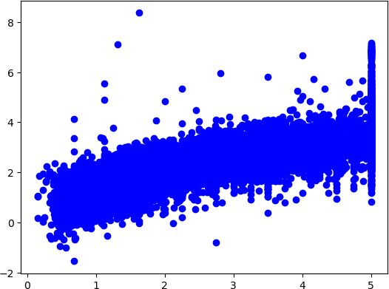

plt.scatter(ytest,ytest_pred ,c='lightgreen',marker='s',label='Test data')

<matplotlib.collections.PathCollection at 0x1e79e5387d0>

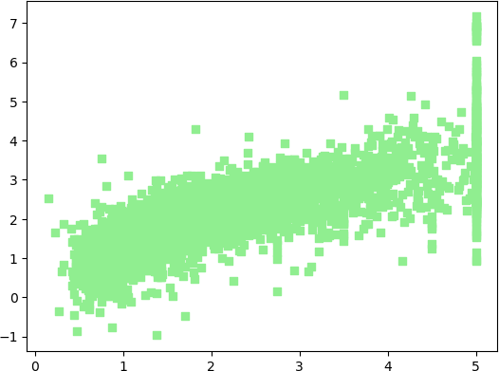

plt.scatter(ytrain ,ytrain_pred,c='blue',marker='o',label='Training data')

plt.scatter(ytest,ytest_pred ,c='lightgreen',marker='s',label='Test data')

plt.xlabel('True values') plt.ylabel('Predicted')

plt.title("True value vs Predicted value") plt.legend(loc= 'upper left')

plt.plot() plt.show()

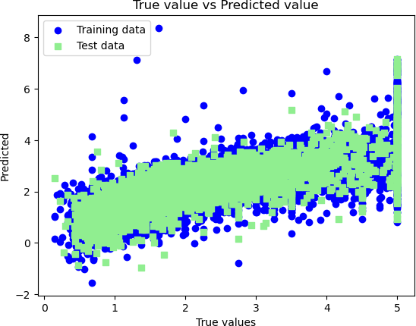

Prathmesh Nakhate B2_13241